
FACULTY OF ENGINEERING, DESIGN AND TECHNOLOGY
Department of Computing and Technology
Trinity 2024 – Semester 2
MSDS – Big Data Analytics | Code – DSC8201
By: Econia Racheal, Access Number: B26253

Using the attached sample data generate some visualisations (whichever you like) that you can show to top management in a dashboard. Be as creative as possible.
Submit screenshots of your visualisations to my email address. kayebare@ucu.ac.ug

The Electric_Vehicle_Population_Data_class dataset is quite large, and while I may not have specific domain expertise in this area, I was able to analyze the variables and create visualizations that provide insights into key trends. These visualizations highlight the most popular car models by year of production or consumer preference, looked at the Clean Alternative Fuel Vehicle (CAFV) Eligibility on the different car makes, the distribution and count of different electric vehicle types, the most manufactured electric vehicle type, car makes across different years, and the geographical distribution of electric vehicles.

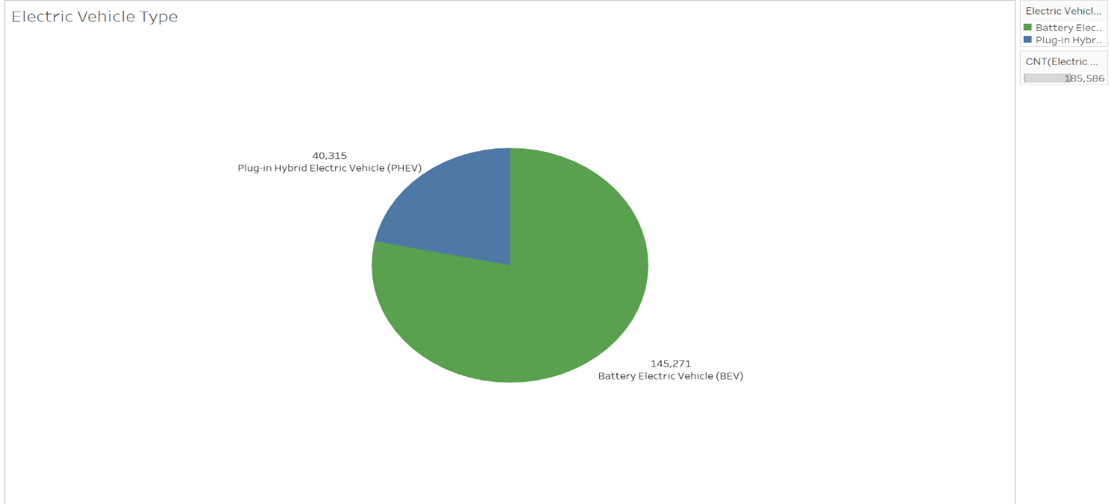

Battery Electric Vehicles (BEVs) are more prevalent than Plug-in Hybrid Electric Vehicles (PHEVs), suggesting that BEVs may be produced in greater numbers due to their higher preference over PHEVs.
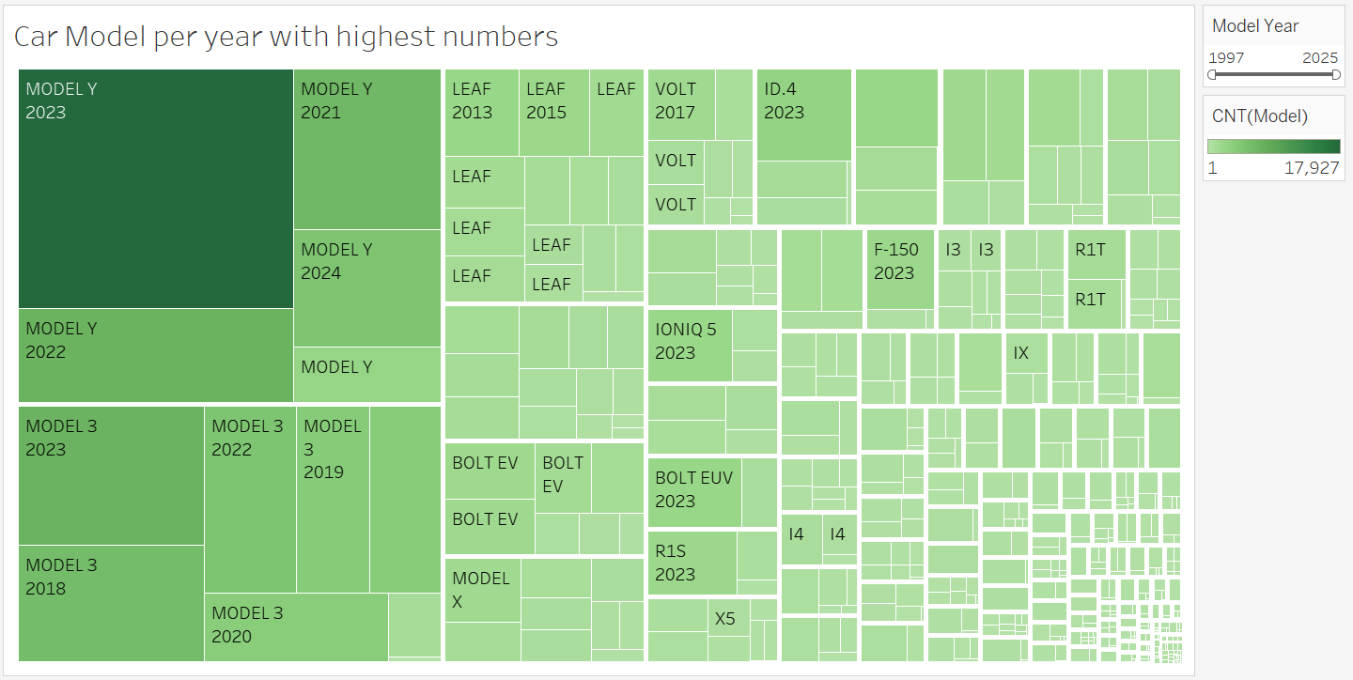
The visualization reveals that Model Y from 2023 has the highest number of units, with strong representation in 2024 and 2021 as well. Model 3 from 2023 follows closely, along with its variants from other years. The remaining models have significantly lower counts. This suggests that these two models are more popular and thus have higher production numbers.

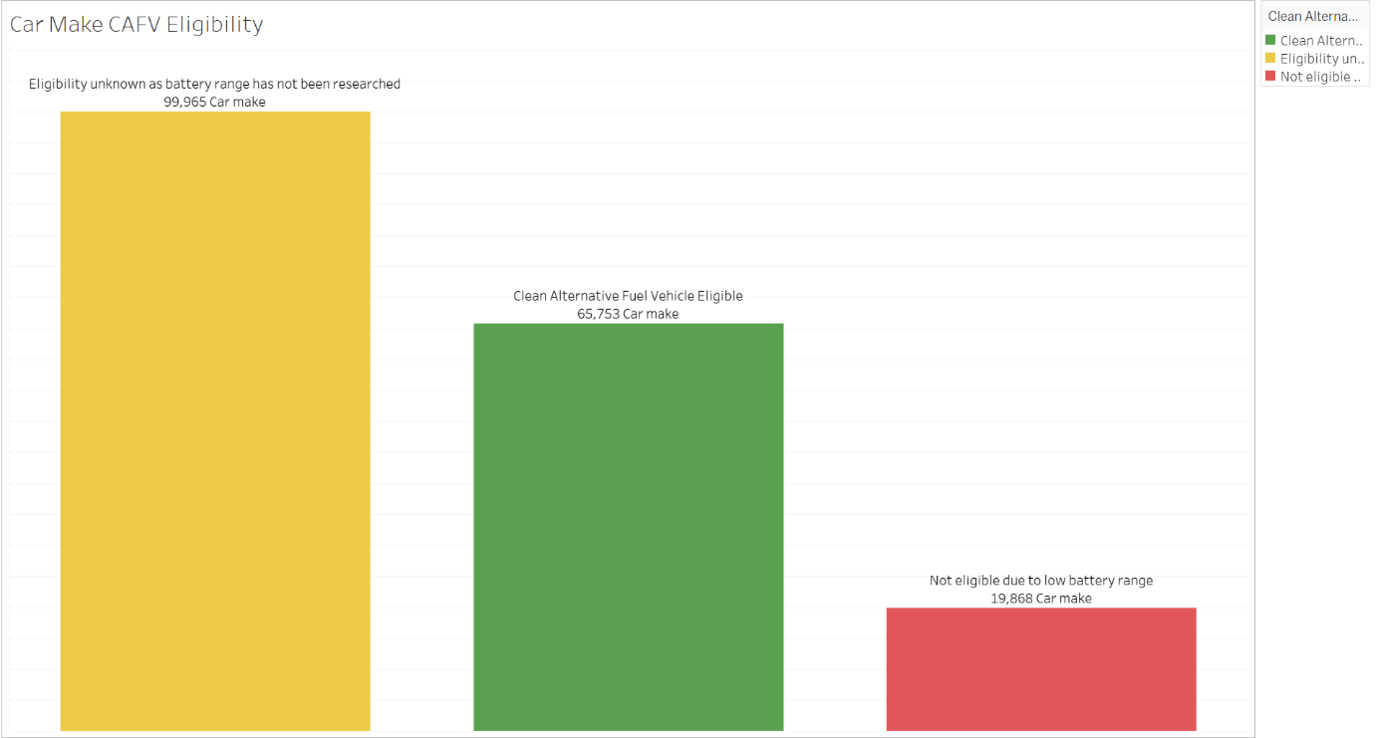
Most of the car make eligibility to CAFV is unknown as battery range has not been researched, 65,753 Car make are eligible to clean alternative fuel vehicle and 19,868 are not eligible.

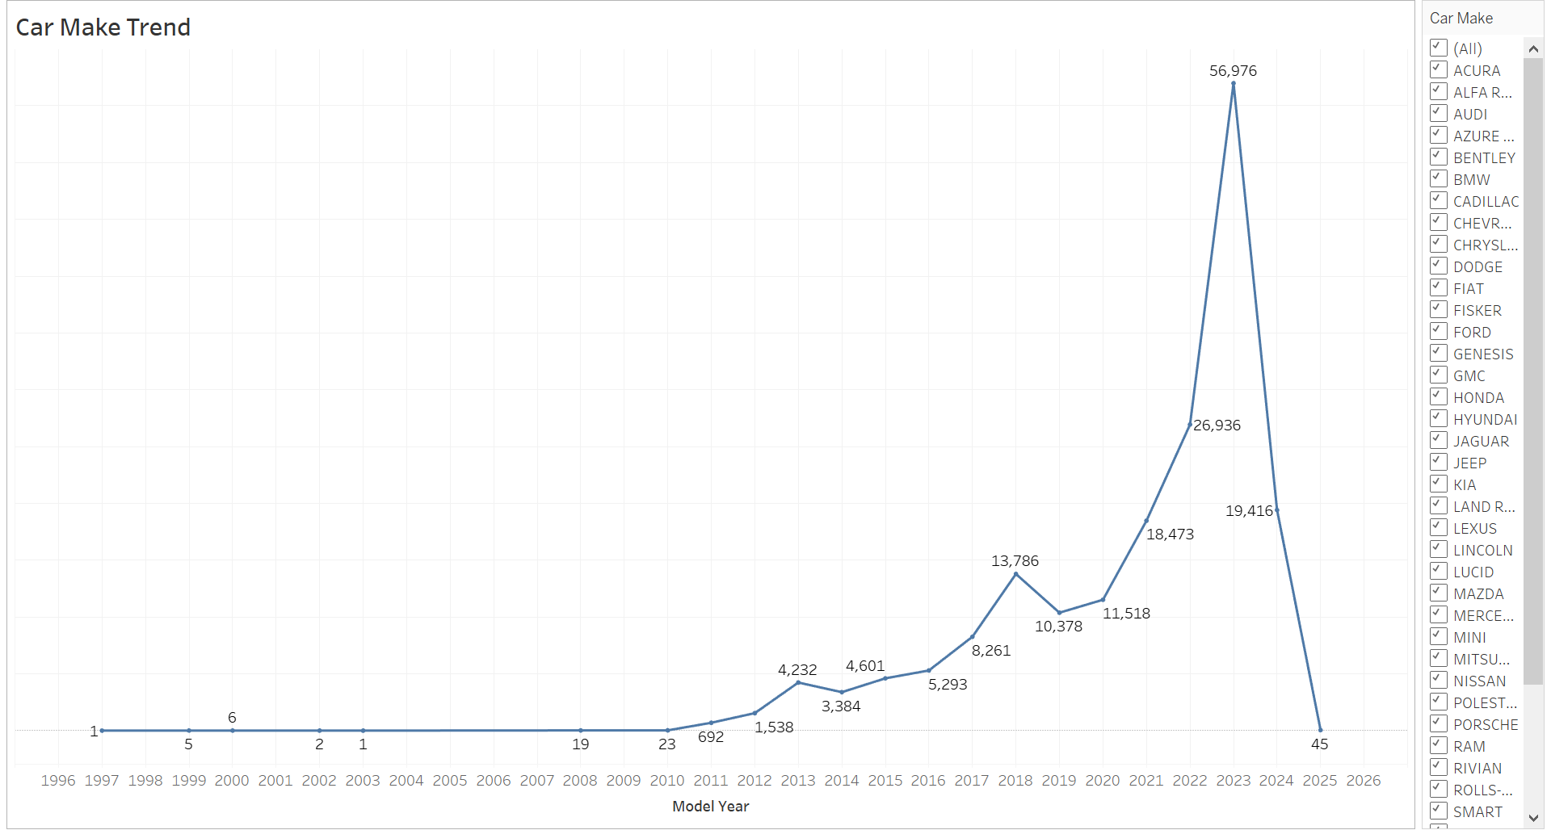
The line graph shows us the trend of the Car Make in the different years. Looking at the model that was most populated in the previous graph I realised the Model Y cars were highly populated therefore a follow-up on the make when filtered we notice that Tesla has the highest numbers throughout the year having their highest on 26,902.

THE DASHBOARD
